Experiment – 7
Topic : Experiment with different layouts and color schemes for an app.
Name : RAGHURAM
Reg no: 240701812

Collect user feedback on aesthetics and usability using GIMP(GNU
Image Manipulation Program (GIMP)

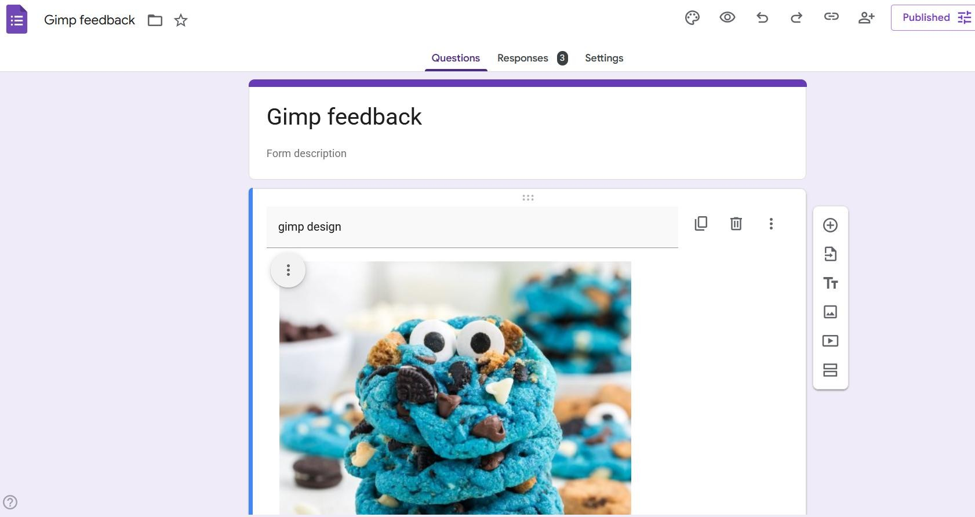
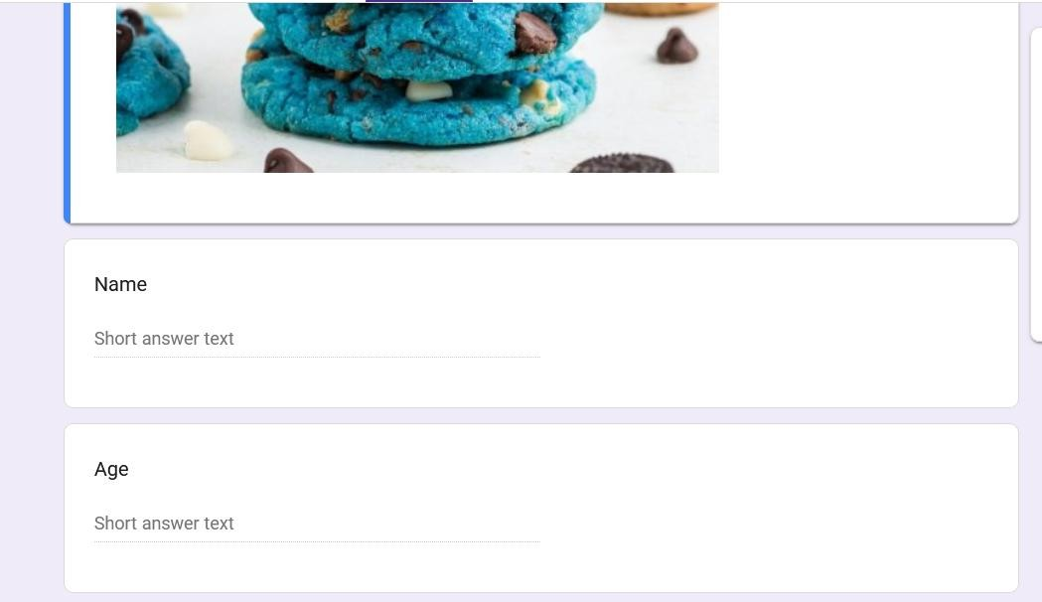
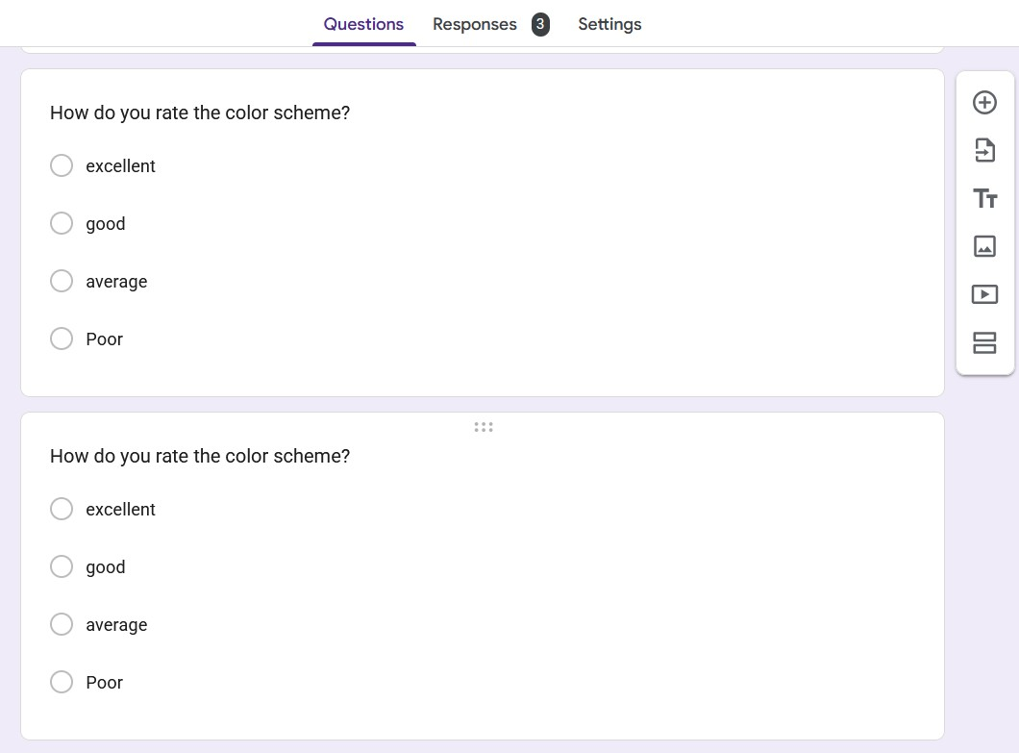
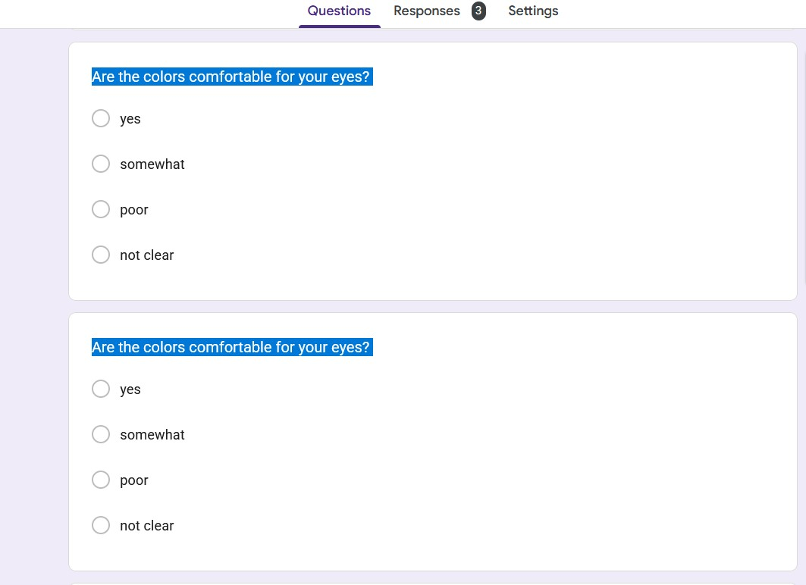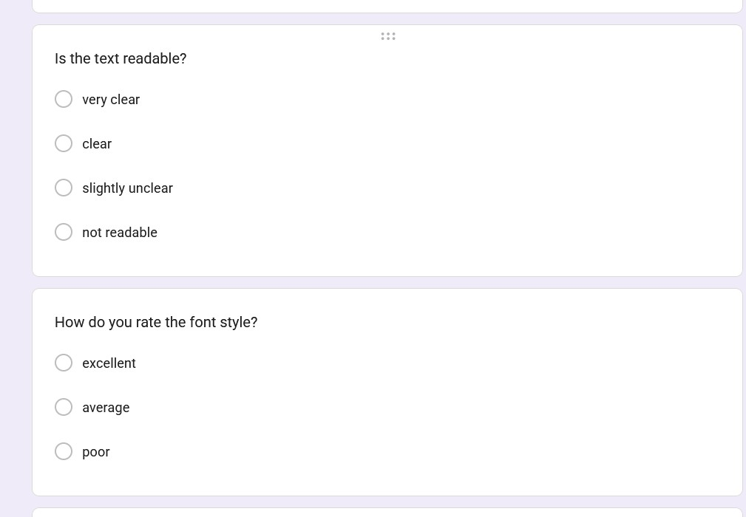
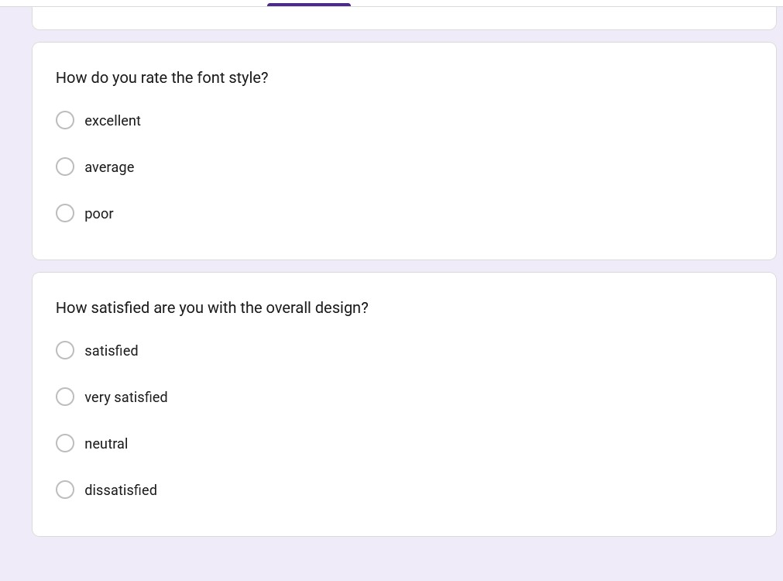
About the experiment :

User Interface (UI) design focuses on improving the look and feel of an application. A good design ensures:
- Better user experience (UX)
- Easy navigation
- Attractive visuals
GIMP is a free tool used to create and edit UI designs, including layouts, colors, icons, and screens.
Different layouts and color schemes were successfully created using GIMP. Based on user feedback, simple layouts with balanced colors provided better usability and visual appeal.
Conclusion
The experiment shows that UI design plays a crucial role in user satisfaction. Collecting feedback helps improve the app’s design, making it more user-friendly and visually appealing

